Explainable AI



You can train a machine learning model to recognise what is in an image. The model will only tell you what the overall picture is. It doesn’t tell you the reason for the answer it gives you, or which parts of the image led it to give that answer.

In this project, you will learn a simple technique for understanding why an image classifier gives the answers that it does. You’ll make a tool in Scratch that will help explain the parts of an image that your machine learning model recognized.

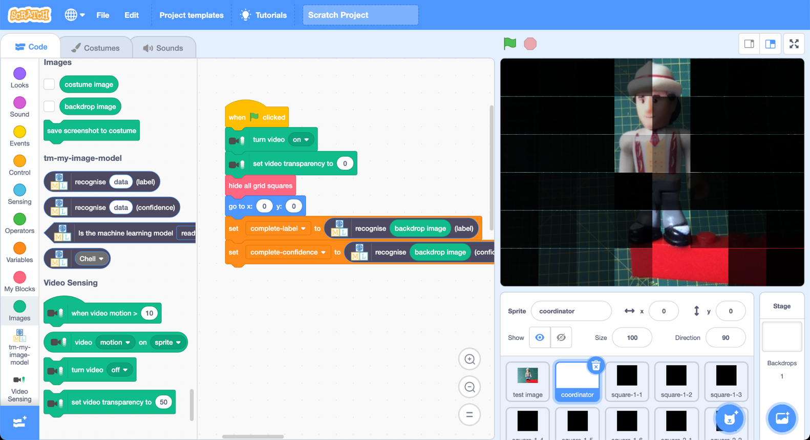

This project worksheet is licensed under a Creative Commons Attribution Non-Commercial Share-Alike License

http://creativecommons.org/licenses/by-nc-sa/4.0/

1. Choose four small objects to train the computer to recognise.   
   *It helps if the objects are a similar size and have something in similar about their appearance.  
   For example, I used four different character toy figures.  
   A group of toy figurines

   Description automatically generated with medium confidence*
2. Go to [https://teachablemachine.withgoogle.com](https://teachablemachine.withgoogle.com/) in a web browser
3. Click on “**Get started**”  
   
4. Click on “**Image Project**”  
   Graphical user interface, website

   Description automatically generated
5. Click on “**Standard image model**”   
   Graphical user interface, application

   Description automatically generated
6. Click on the “**Add a class**” button twice, to create **four** classes  
   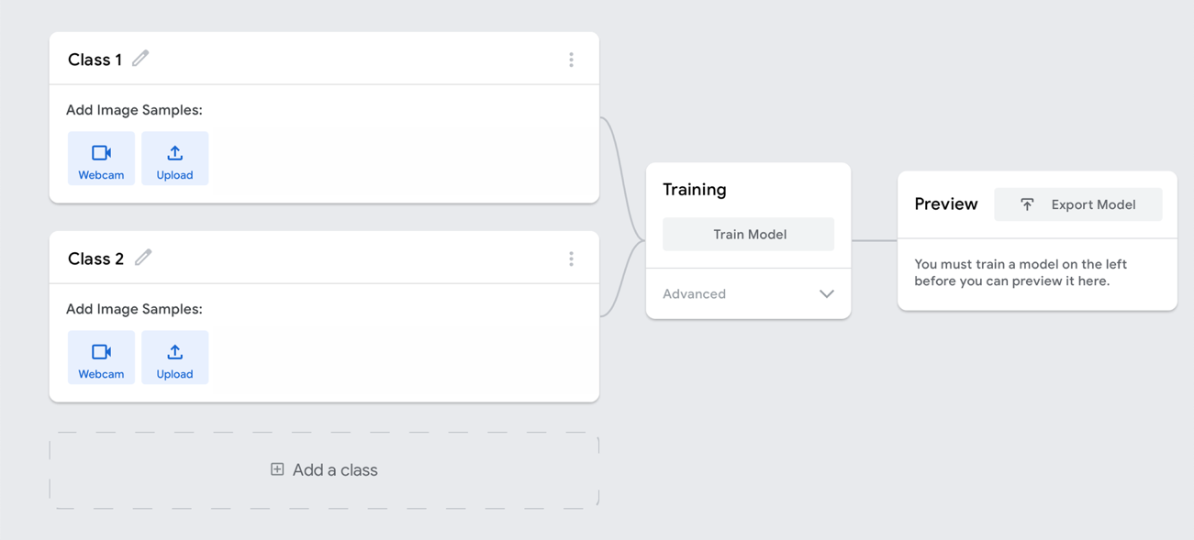
7. Click the **pencil** buttons to name the classes after your four objects  
   Graphical user interface, application

   Description automatically generated
8. Use the “**webcam**” button to take photos of your object  
   Graphical user interface, application

   Description automatically generated  
     
   *Make sure the background is identical in all of your photos.*  
     
   Graphical user interface, application

   Description automatically generated  
      
   *Notice how I avoided having my fingers in the photos. If you can’t do that, try to keep the position and shape of your hand consistent in all of your photos, so only the object is different.*   
     
   **Important:** You should vary the location of your object in all your photos.  
   Move the object around in the webcam view while you hold down the “**Hold to Record**” button.
9. Once you have taken 250 images of each of your objects, click on the “**Train Model**” button  
   Graphical user interface

   Description automatically generated
10. Use the “**Preview**” to check that your model is working well  
    *You can try adding more examples and training again if it isn’t.*   
    Graphical user interface

    Description automatically generated
11. Click on “**Export Model**”  
    Graphical user interface

    Description automatically generated
12. Click on “**Upload my model**”  
    Graphical user interface, text, application, email

    Description automatically generated
13. Copy the model link – you’ll need this in a moment  
    Graphical user interface, text, application, email

    Description automatically generated
14. Go to <https://machinelearningforkids.co.uk/pretrained>  
    Graphical user interface, text, application

    Description automatically generated
15. Click on the “**Open a TensorFlow model**” button  
    Graphical user interface, text, application, email, website

    Description automatically generated
16. Paste in the link you copied in Step 13  
    Graphical user interface, application, Teams

    Description automatically generated
17. Click on “**Open Scratch**”
18. Click on the “**Project templates**” menu button  
    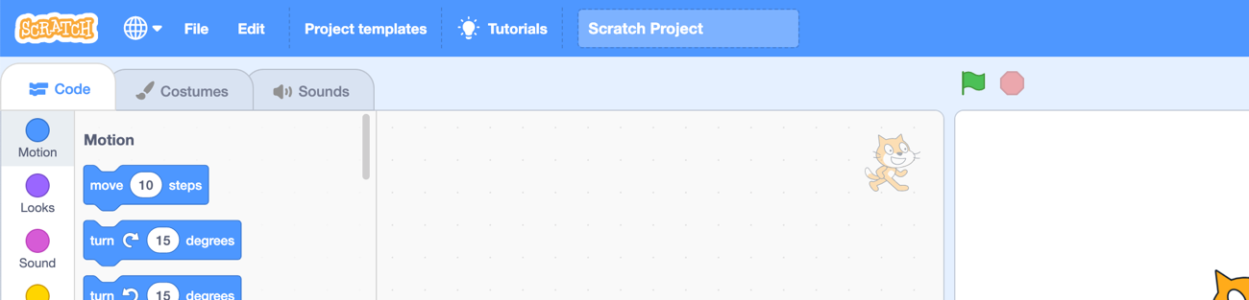
19. Click on the “**Explainability**” project template
20. Click on the “**test image**” sprite  
    Graphical user interface, text, application, chat or text message

    Description automatically generated
21. Click on the Green Flag button
22. Hold one of your objects up to the webcam and press “w” on your keyboard to take a photo  
    **Important:** The background must be identical to the background you used for your training photos. *Try to position your object centrally.   
    Try to hold your object close enough to the webcam so that it fills a lot of the picture.  
    If you’re not happy with the photo, press “w” again to take a new one.*  
    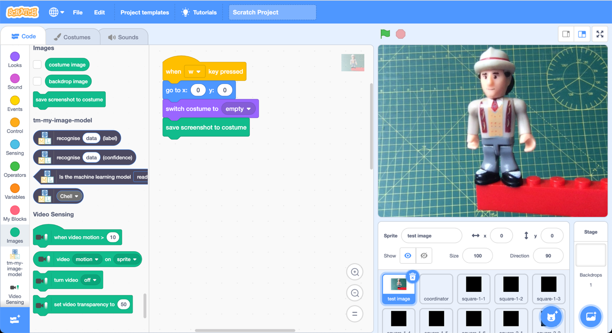
23. Create the following script  
    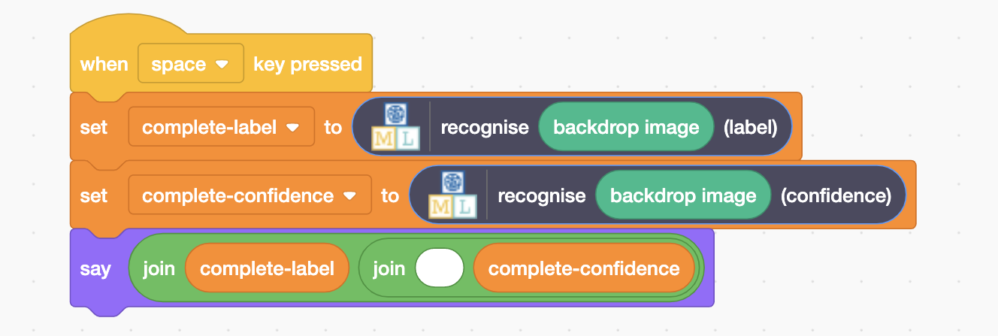
24. Press your spacebar  
    *Make a note of the confidence score – you will need it again later.*  
    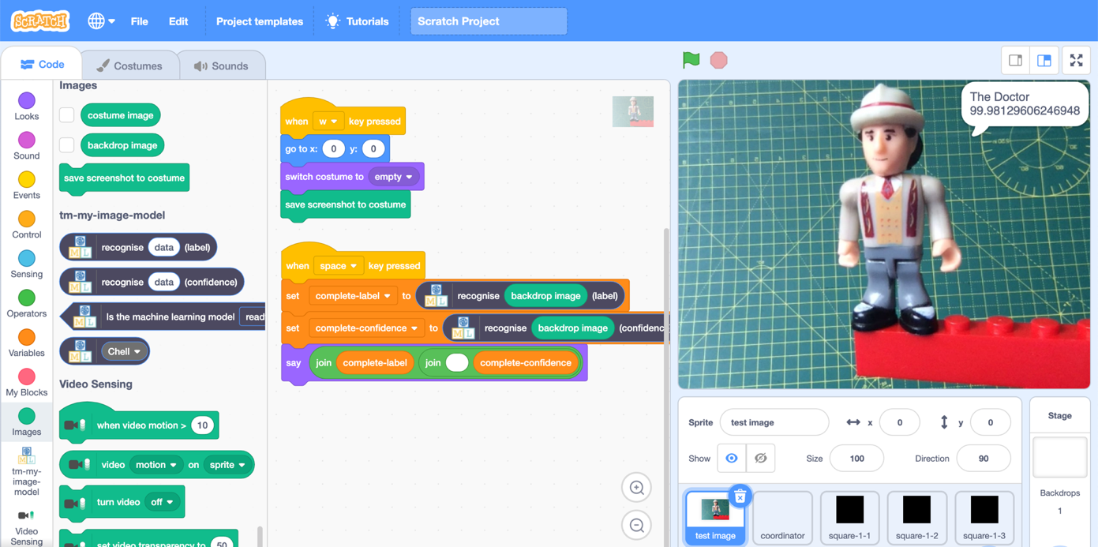

**What have you done so far?**

You’ve trained a machine learning model to recognize images of a few objects. The machine learning model can tell you it’s prediction of what it thinks is in an image, but it doesn’t tell you **why** it made that prediction.

It doesn’t tell you what parts of the image were significant for the prediction, and what parts of the image the model thought were irrelevant.

Next, we’ll see how you can learn a little about what your model thinks is most important in your test image.

1. Create a new sprite using the “**Paint**” option  
   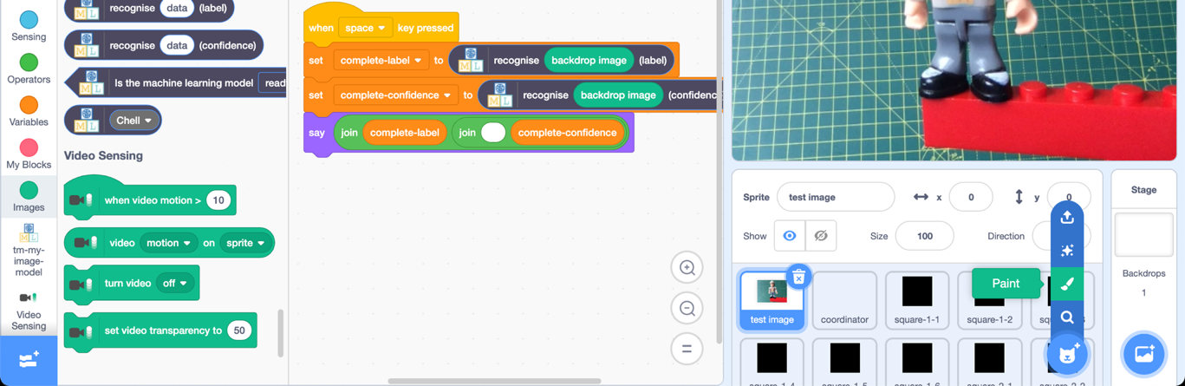
2. Draw a solid filled square   
   *Choose a colour that won’t give a hint to your machine learning model to choose one of the objects.  
   * a colour that isn’t uniquely used by one of your objects.  
   * a colour that is in none of your objects, or used equally in all of them.   
   For example, I chose black because none of my four toy characters are mostly black.*  
   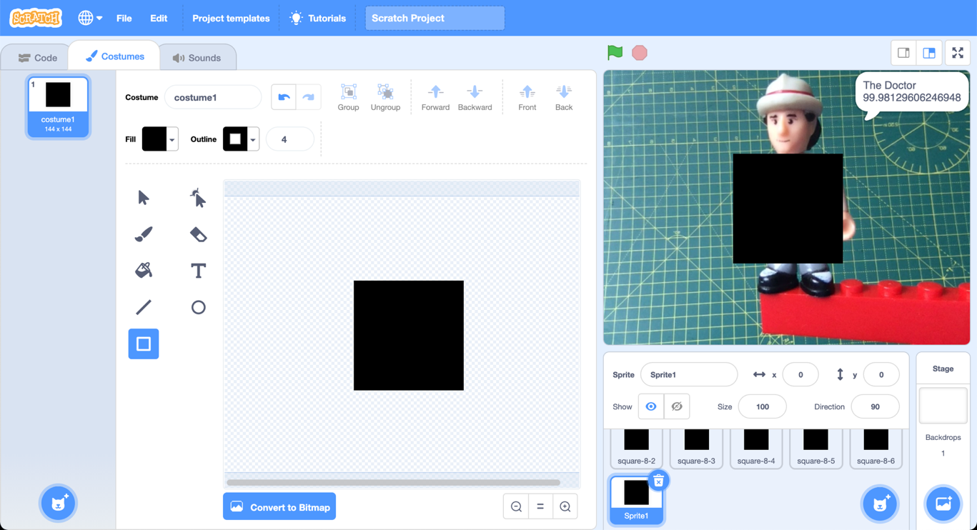
3. Drag the sprite to a position on the stage that is as far away from your object as possible
4. Press the spacebar again  
   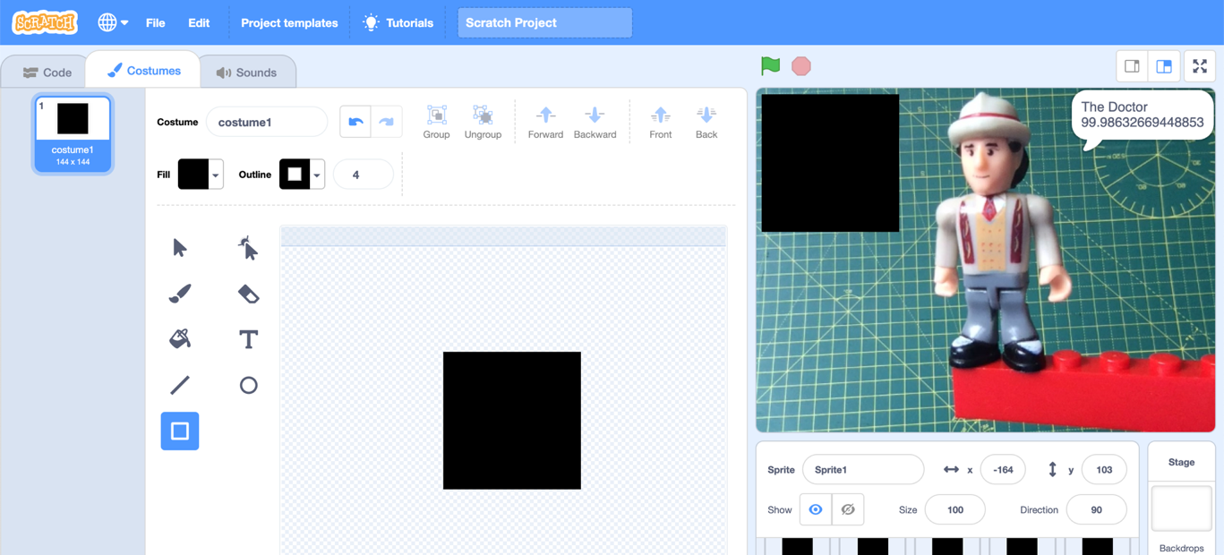
5. Compare the prediction your machine learning model makes with the prediction from Step 24  
   *The confidence level should be very similar to the confidence from Step 24.  
   Covering up this area has not made much difference to the prediction.   
   The area you covered up was not very significant to the prediction.   
   The contents of that square did not have much to do with why the model thought this image looked like your object.*
6. Move the square sprite to a position that covers something you think is going to be very significant
7. Press the spacebar again  
   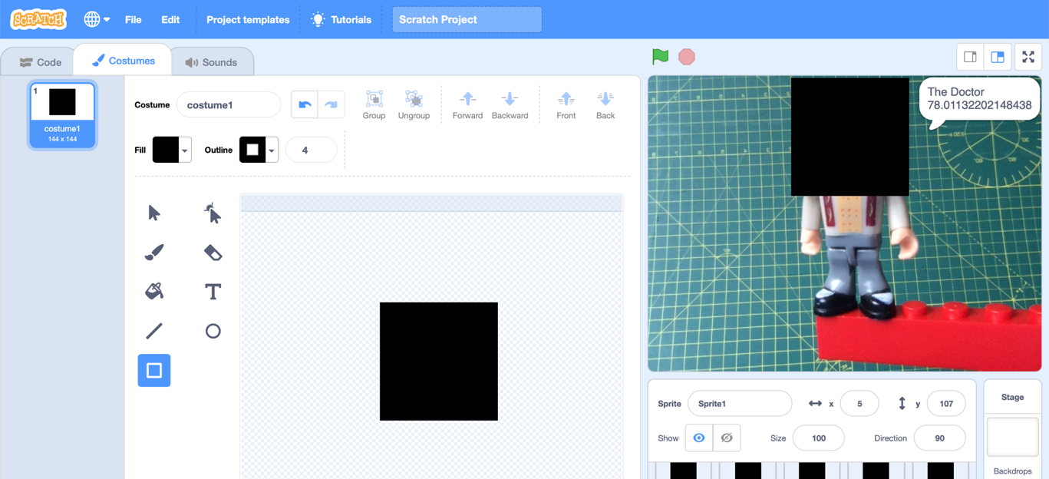
8. Compare the prediction your machine learning model makes with the prediction from Step 24  
   *The confidence level should be different to the confidence from Step 24.  
   Covering up this area made a difference to the prediction.   
   The area you covered up was significant to the prediction.   
   The contents of that square had something to do with why the model thought this image looked like your object.  
   The model might still have recognized the object correctly, but without the area you covered up, it wasn’t as confident in the prediction.*
9. Repeat Steps 30-32   
   *Try to find a position that makes the biggest difference on the machine learning model’s prediction*  
   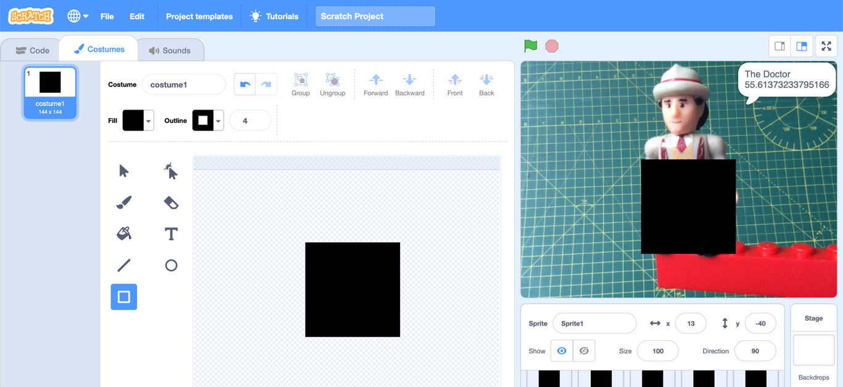 *If you find this difficult…   
     
   If every part of your object is visually unique and distinctive, then there will always be something for your machine learning model to recognize – this can mean that covering up one part of the image doesn’t make a big difference to the confidence.  
     
   If this happens, you can:  
   * press “w” to take a new photo of a different one of your objects  
   * make your square sprite larger so it covers even more of your image  
     
   Because all of my objects were toy character figures, they all had something in common, so covering up distinctive features did make a difference to the confidence.   
     
   But if you trained your machine learning model really well, then it might be difficult to fool your model easily!*

**What have you done so far?**

You’ve seen that although a machine learning model makes a prediction for an image as a whole, different areas of the image have different levels of significance to the prediction.

You’ve seen a simple way to measure this is to cover parts of the image and see the difference that it makes to the confidence the model has.

Finally, you will try a more organised way to use this technique – moving the cover square to every possible location and seeing the difference it makes in each position.

1. Hide your black square sprite  
   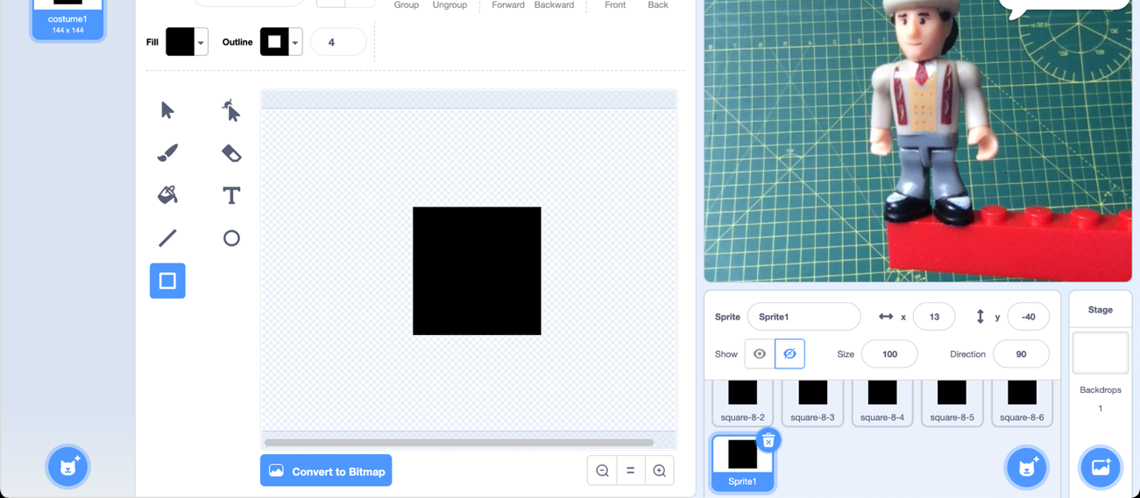
2. Click on the “**coordinator**” sprite and find the **Green Flag** code  
   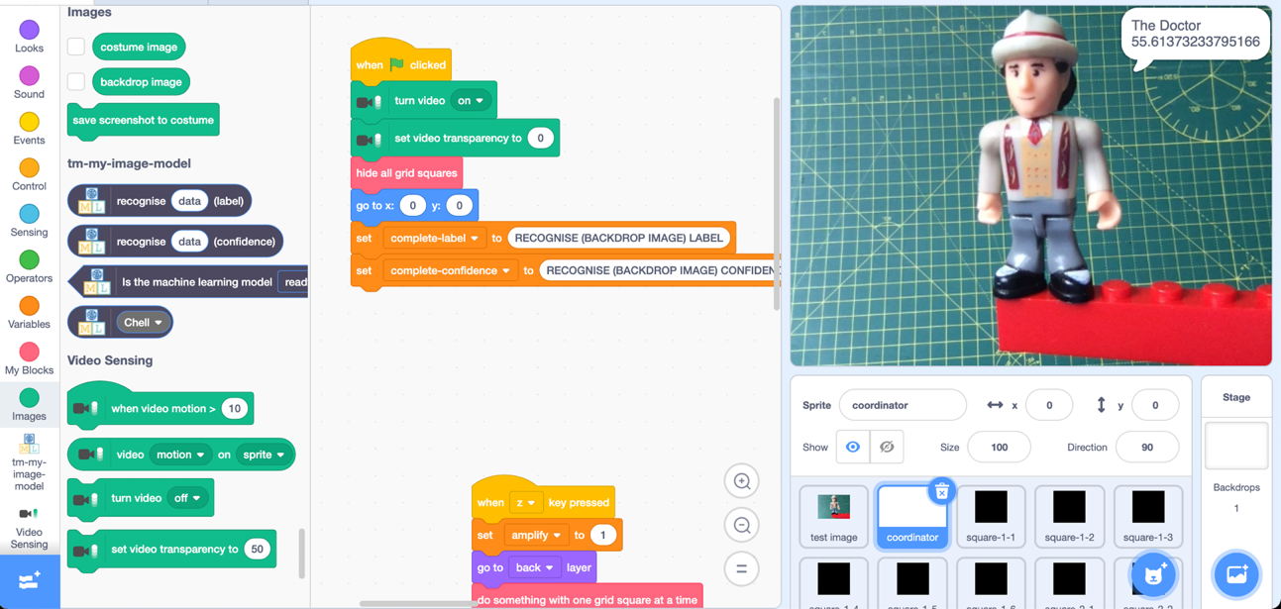
3. Update the code to look like this  
   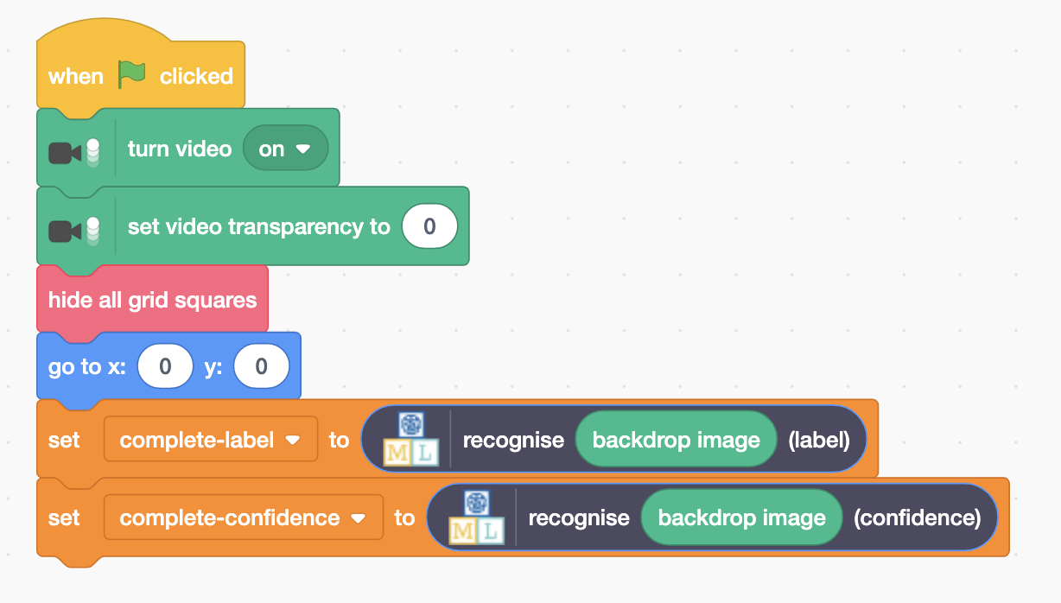
4. Find the “**do something**” code  
   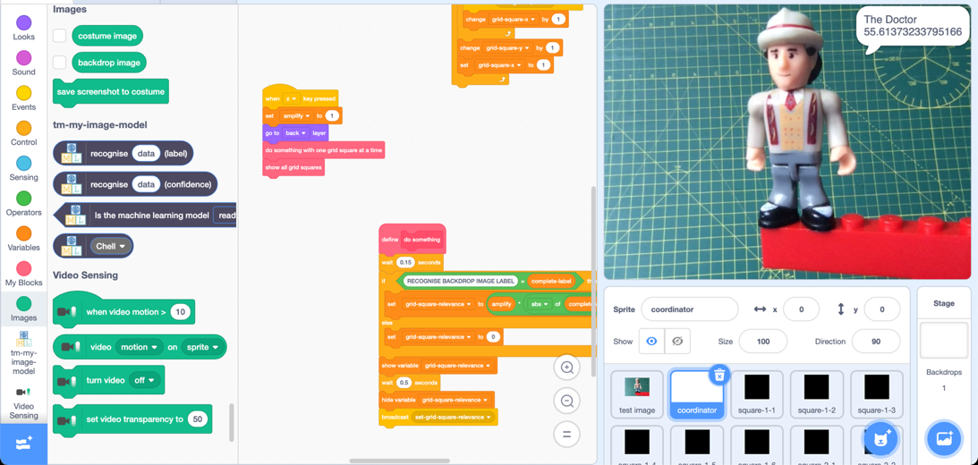
5. Update the code to look like this   
   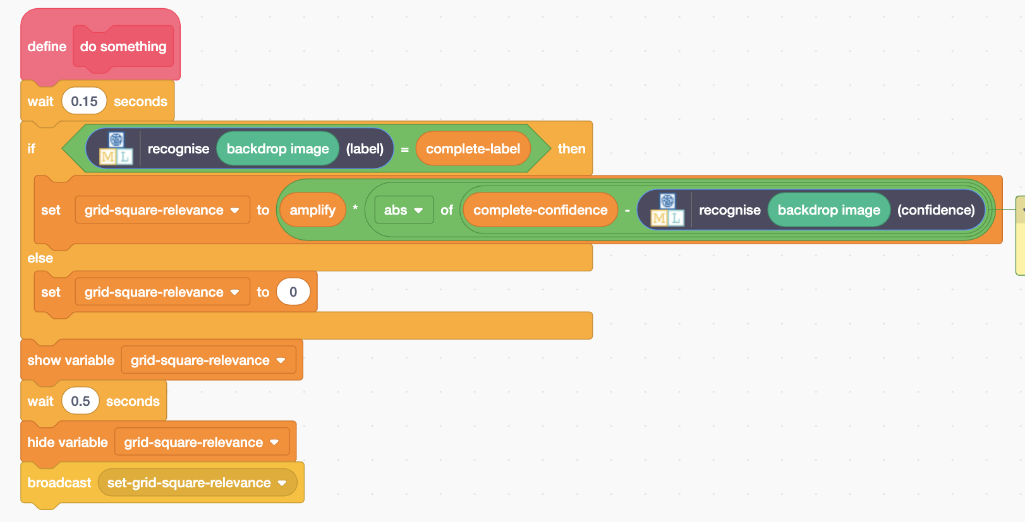
6. Click the **Green Flag**
7. Press the **z** key on your keyboard  
   *A square will be shown in every location in turn. The difference it makes to the machine learning model’s confidence will be displayed.  
   When it finishes, a visualisation will be displayed that shows the difference each area made on the model confidence.*Graphical user interface, application

   Description automatically generated
8. Find the code where the amplify variable is set  
   *The amplify variable controls how much of a difference the confidence score has on the visualisation.*   
   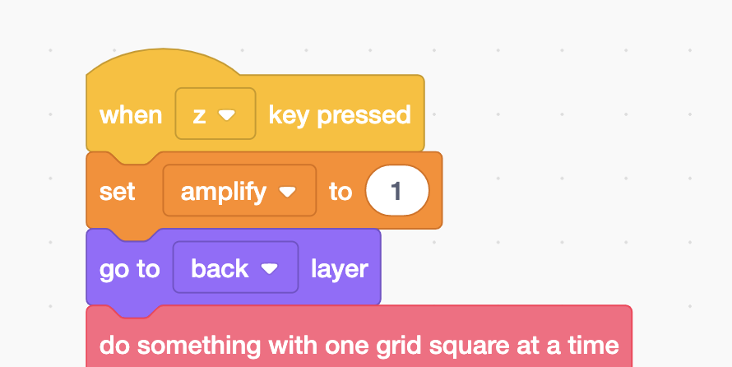  
     
   *You will need to experiment to find the right value for this variable.*  
   *Change the number in the code  
   Then re-run the test by:  
   * clicking the Green Flag  
   * pressing the z key on the keyboard*
9. If you don’t see any transparent sections, **increase** the amplify value 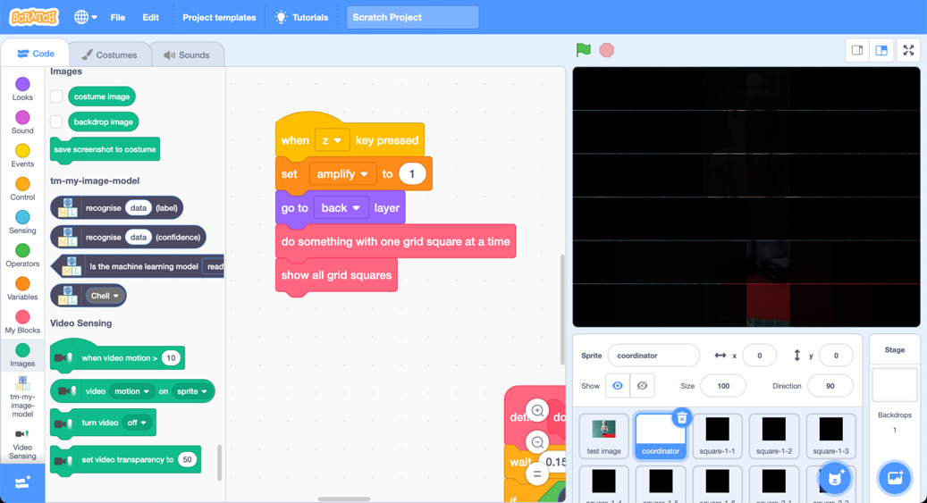
10. If you see too many transparent sections, **decrease** amplify   
    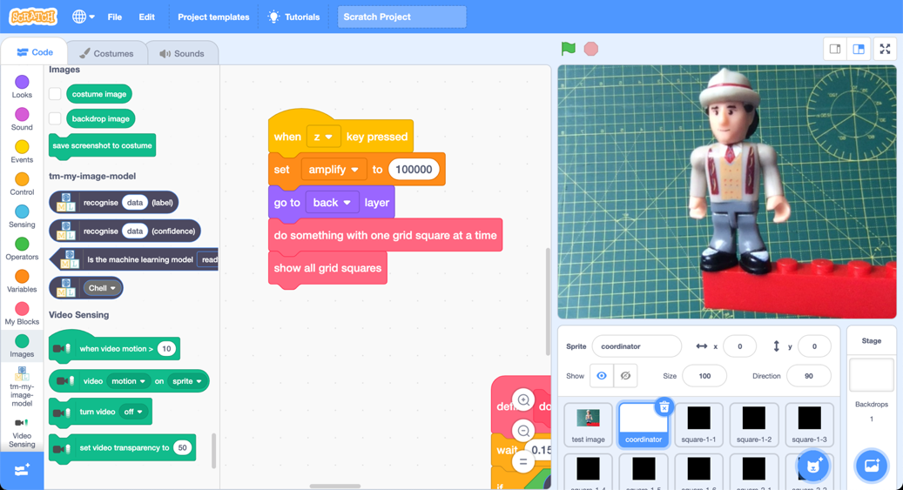
11. If you get the right value, the visualisation will look like this:  
    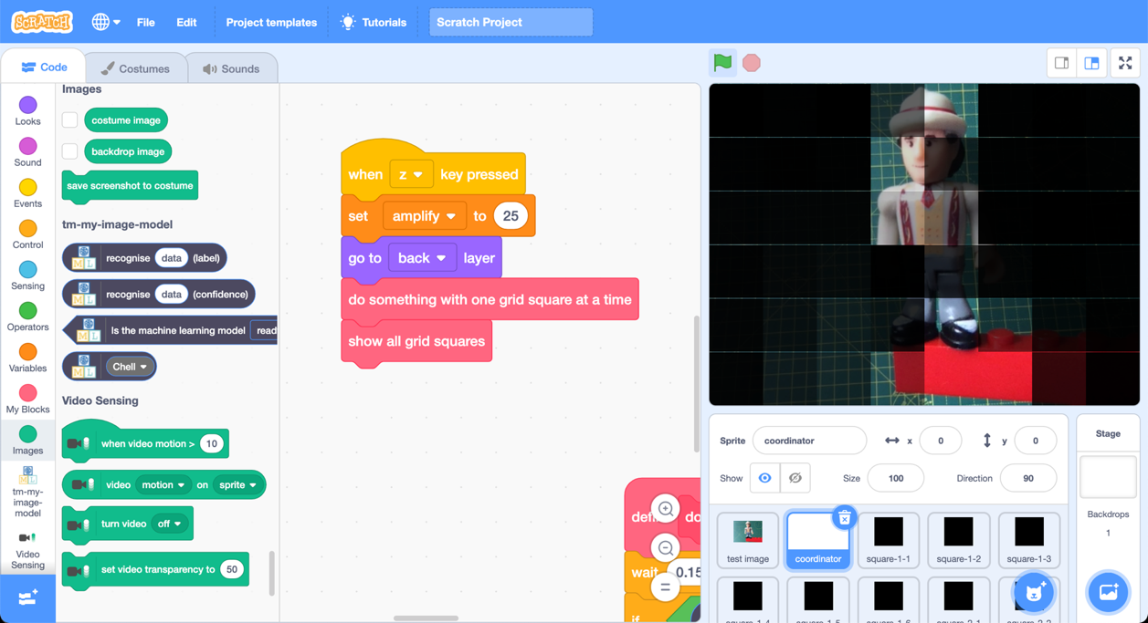

**What have you done?**

You’ve trained a machine learning model to recognize images of a few objects. The machine learning model can tell you it’s prediction of what it thinks is in an image, but it doesn’t tell you **why** it made that prediction.

You made a simple visualisation to display the significance that different parts of the image have on the prediction. Areas with very little significance for the confidence the machine learning model has in its prediction are shown in black. Areas with a lot of significance are shown as fully transparent.

The overall visualisation gives you an approximate idea of the parts of the image that the machine learning model found to be most relevant. The more a section is covered, the less relevant it was too the prediction.

**Did you know?**

Finding ways to help us understand the answers that our machine learning systems give us is a busy area of artificial intelligence work called “**Explainable AI**” (or “XAI”).

The following links can help you learn more about the sort of work that is happening in Explainable AI.

**Royal Society**

The Royal Society have written a short report that explains why Explainable AI is so important, and some of the challenges involved in doing it.

Go to [ibm.biz/**explainableai-royalsociety**](https://ibm.biz/explainableai-royalsociety)

**AI Explainability 360**

AI Explainability 360 Toolkit is a free open-source toolkit from IBM Research that helps people to understand how machine learning models create their answers.

Go to [ibm.biz/**explainableai-ibmresearch**](https://ibm.biz/explainableai-ibmresearch)

**IBM**

IBM’s Explainable AI website is a good example of how important businesses think XAI is going to be.   
  
Go to [ibm.biz/**explainableai-ibm**](https://ibm.biz/explainableai-ibm)